Team Names:___________________________  _______________________________________  Car Name: ______________________________  Objective: Use Scientific knowledge and Engineering skills to develop and test an efficient, strong and fast prototype car.  Advice from the Bloodhound Engineers:  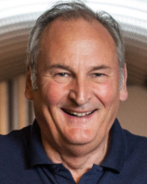  When you’ve finished testing your car, write your own advice here:  Keep the design as simple as possible, a lighter car will be faster’  Jenna Gaff, Design Engineer.  ‘Try different tyres out to see which suits your terrain’ Richard Noble OBE Project Director. | Engineers use an iterative design process, they design, test, analyse then adapt their designs, then retest them again and again to make improvements.  Build your car then run it once…  Run Distance (m) Time taken (s) Speed (m/s) Mass (g)  1  2  3  Speed = distance/ time  Acceleration = (final speed – initial speed ) time  Force = mass x acceleration  Sketch some design ideas here  Analyse the run – what didn’t go to plan?  Suggest Some Improvements

