**BLOODHOUND Matters**

BLOODHOUND SSC is made millions of atoms, just like everything else in the Universe. In this activity we’ll learn how the arrangement of these particles helps give the materials the properties we need to build a 1000mph car.

1.How are the particles of Solids, Liquids, and Gases arranged? Use these keywords to help: RANDOM, ORDERED, CLOSE, FAR, VIBRATING, MOVING QUICKLY, FLOWING



|  |  |  |  |
| --- | --- | --- | --- |
|  | Solid | Liquid | Gas |
| Arrangement of particles: |  |  |  |
| Movement of Particles: |  |  |  |
| Closeness of particles: |  |  |  |

**Changing States.**

3. Particles are often changing from one ***_______***to another. In Newquay, the ***_______*** water vapour in the air cooled down, and ***_________*** when it hit the canopy, making it hard for Andy to see. When it was cold overnight, we were worried that this water would ***________*** and become ice, which could damage the cockpit controls. In our rocket, ***______*** hydrogen peroxide will ***_________*** into gas as it is heated. Cold, flowing air prevents the jet engine ***_______*** itself, going from  ***_______*** to liquid. The carbon making up the cockpit does not melt, it ***________***– going straight from solid to liquid, but only at

6000°C, which is the temperature of the outside of our Sun.

Add in these Missing Keywords:

**solidify liquid gaseous condensed state evaporate melting sublimes solid.**

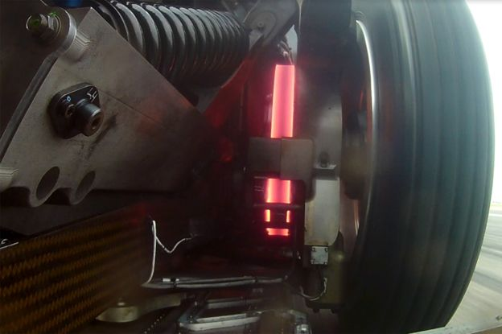

4. During the test runs of BLOODHOUND, the brake disks began to overheat. Describe what is happening to the particles in the brakes.

REMEMBER THE PARTICLES DON’T CHANGE IN SIZE.

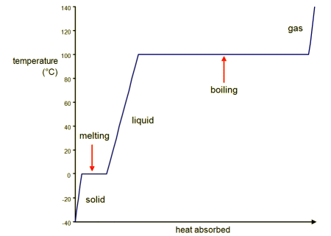

5. this is a graph shows how water changes state at different temperatures. Energy from heating is used to break bonds between the particles as it changes state.

1. At what temperature does water normally freeze?

1. At what temperature does water boil?
2. What state is the water in at 65°C?

6. Jet Fuel evaporates at a different temperature to water. Plot this data on the graph, then add labels for the states and state changes.



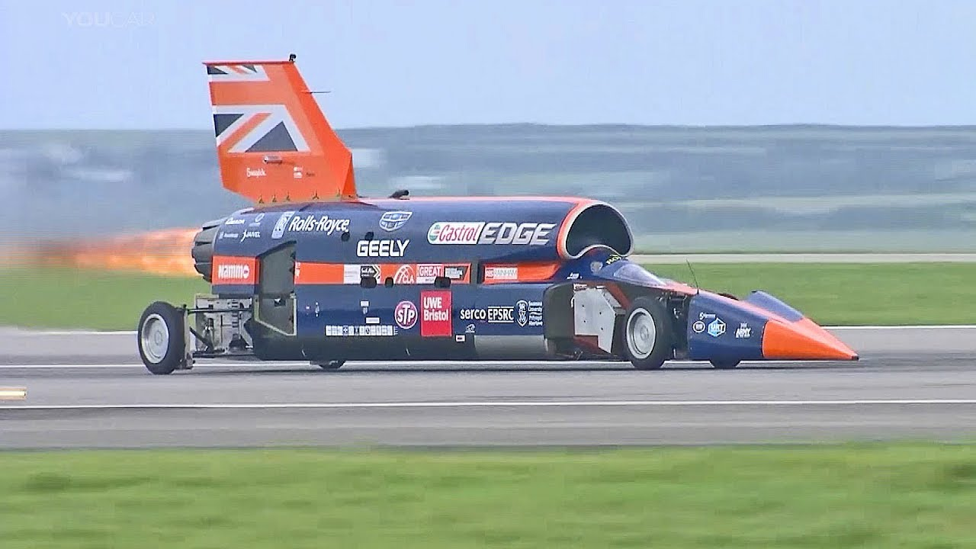

7. Describe the differences between the cooling curves of jet fuel and water, stating data with the patterns and trends.

8. EXTENSION: Imagine water got into the fuel tank - would the fuel sink or float? Draw and label a diagram to explain the differences in the spacing of the particles between water and jet fuel.